Patient-1 Harsha Mohit

T1. Finding the patient

T2. Adding the diagnosis based on the demographics and vitals of the patient.

T3. Medication used to treat this diagnosis. Creating prescription order.

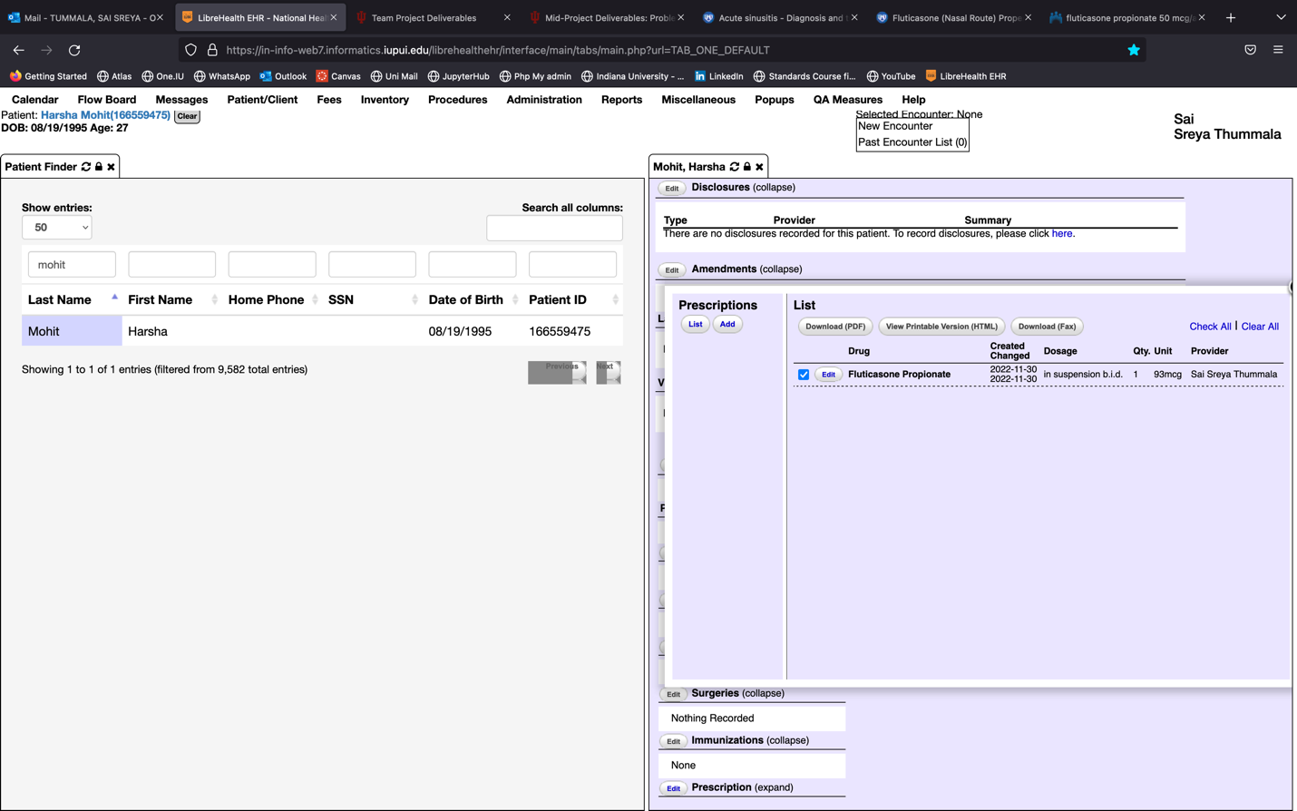

T4. Creating a new encounter at the emergency department to describe the misadventure.

T5. Adding the misadventure to the patient’s medical problem list.

T6. Including the ICD-10 code to the misadventure.

T7. Reviewing the systems of the patient.

T8. Medication used to treat misadventure and creating a prescription for it.

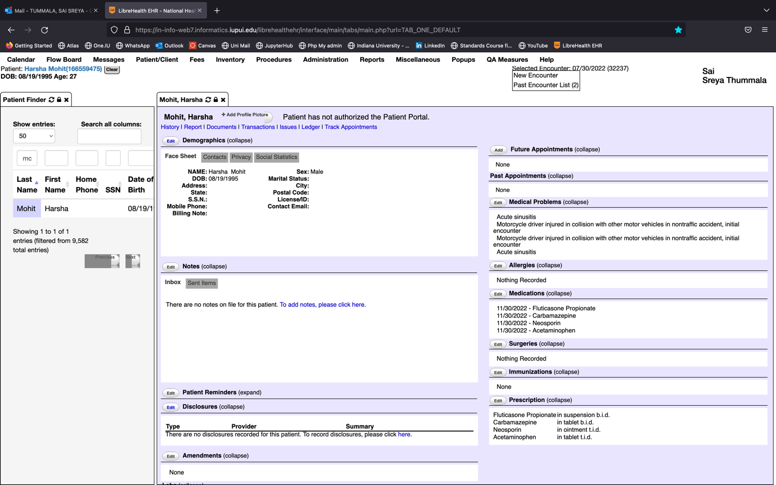

T9. Referring the patient to Neurologist.

Creating an encounter for referral and scheduling follow up.

